(Approx. 663 words)

AutoMatting ™ – Unique Digital Matts ... Extraordinaire
From Image Trends Inc. – The Science of Imaging
by Neil Longmuir, a member of the Winnipeg PC User Group Inc., Canada
www.wpcusrgrp.org
longmur(at)ms.umanitoba.ca

Obtained from APCUG with the author's permission for publication by APCUG member groups.

“AutoMatting automatically creates a unique matt for each image which is designed to make the photographer's work more attractive and appealing to the customer in a slide show or viewing mode.” AutoMatting is a digital matting software program that creates a unique matt for each image. The traditional way to display photographs, was to mount the photograph to a matt board, and fit that mounted photograph into a matt opening cut to the size of the photograph. Matting a photograph helps separate the photograph from the surrounding background. Matting a photograph gives each photograph it’s own visual unique and attractive look.

The way images are shown to customers, friends or family tends to be a bit boring. A set of prints is made from a roll of film or digital images. The pictures would be taken out of the photo lab envelope and passed around to customers, friends and family to look at.

This approach is fine if there are only a few pictures, but what if there are a large number of images. One solution is to create a slide show. Creating a slide show takes time to create. One major problem with a typical computer monitor or TV display is that the aspect ratio of the monitor or TV is not the same as the standard typical 3x2 aspect ratio of the images. Then, when we mix portrait (vertical) images with landscape (horizontal) images the images are not the same size. Portrait images are smaller than landscape images and have vertical black bars on each side. Landscape images have smaller black bars on the top and bottom. The bottom line is that you want your images to be visually more attractive to the viewer.

The solution to making the images more attractive is to use AutoMatting to create a unique matte for each image in a folder and resize that image to the aspect ratio of any monitor or TV screen.

Also, if there are sub-folders under the main folder, those sub-folders can be included by checking the included sub-folders in the upper left corner. Once the images to be processed are selected, press Process Images at the bottom of the screen.
AutoMatting operates in a batch mode and creates a sub-folder of images using the colors and patterns in the original image plus a unique beveled edge border. The final result is an image that looks great on the display medium with no black bars appearing on the display.
Figure 1 shows basic AutoMatting screen.

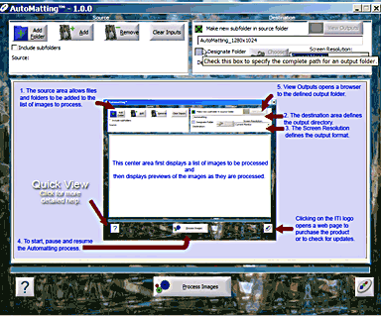

Figure 2 shows the unique matting of a landscape image

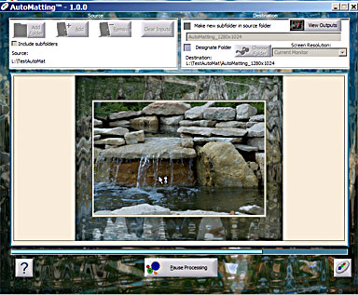

while Figure 3 shows the unique matting of a portrait image. Note in both cases there are no black bars around either image.

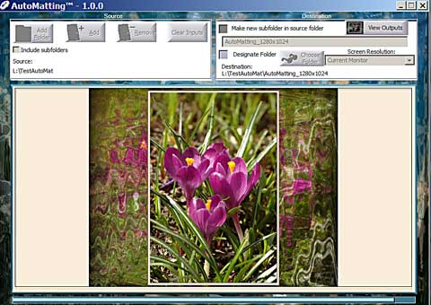

Conclusions
Automatting is a perfect example of a software application that was “thinking outside the box.” This “New Wave” thinking application has given all end users whether they are professional photographers or ordinary every day photographers a great way to show their images to everyone on whatever display medium.
This is a terrific product. AutoMatting is available for a free “try before you buy” download. Visit www.imagetrendsinc.com and download the trial version for yourself. The cost to purchase this program is $49.95 and is available for both the Windows and MAC platforms. This is a very impressive innovative product that works great for a new look to your images.

Neil’s rating (***** – five stars )
I would also like to thank the kind folks at Image Trends Inc. for providing me with a copy of the AutoMatting for review.

This article has been provided to APCUG by the author solely for publication by APCUG member groups. All other uses require the permission of the author (see e-mail address above).

